Row Clock Help

Table of Contents
Row Clock Help 1
Registration 2
Log in 3
Account Management 4
Viewing Results 5
Downloading Results 5
Managing Races 6
Editing Races 6
Basic Race Details 6
Advanced Race Management 7
Entries 7
Entries – Upload 8
Editing Entries and adding a Penalty 9
Timing Points 9
Timing Point Uploads 10
Timing Point Priority 11
Manual Timing Point Uploads 11
Editing Timing Point Upload 12
Split Timing Point Upload 12
Timing Point Upload – Individual Results 12
Handicap Categories 13
Editing results 14
Missing/Blank Numbers 15
New Crews 15
Common Tasks 15
Merging in Backup Results 15
Coping with Timing Marshal putting in the wrong location 15
Coping with “Missing” Numbers 16
Multiple Versions of the same Boat Type and Category 16
Merging Categories 16
Coping with Timing Marshal not changing the location even though they should have 16

Registration
Use the Register button at the top right.
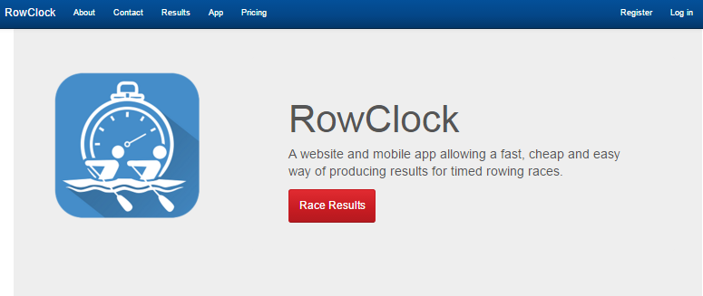
This takes you to the following page. Once you have filled this in, you need to click on the link in the email sent to your email address.
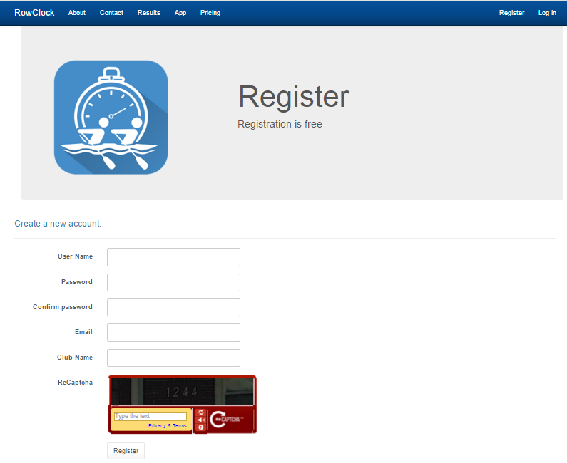
After you do that, log in.

Log in
Log in using the menu button at the top right “Log in”.
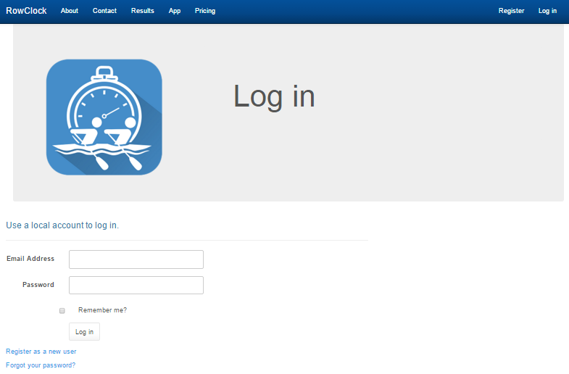
If you have forgotten your password you can follow the “Forgot your password?” link and it will be sent to your email address.
Once you have logged after confirming your email address, in you'll see a new menu item – Races. If you don't, log out and back in again.
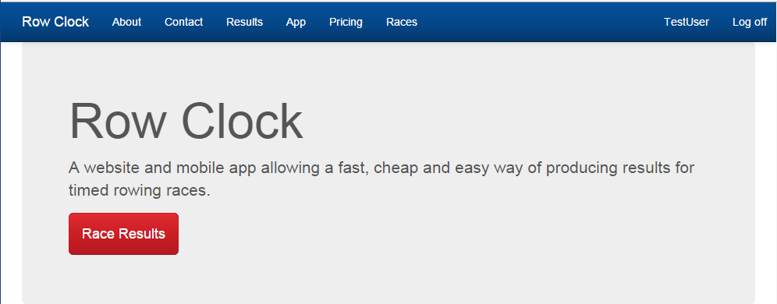

Account Management
When you are logged in account management is available via the button with your user name in it near the top right.
Race management is available fro the “Races” button in the middle.

Viewing Results
Results are available via the “Results” menu button, or via the big red button on the home screen.
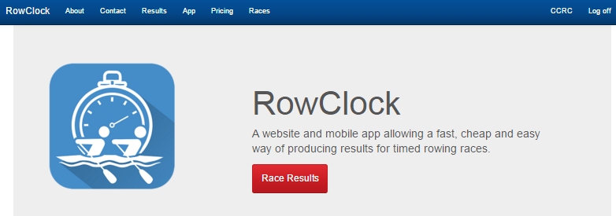

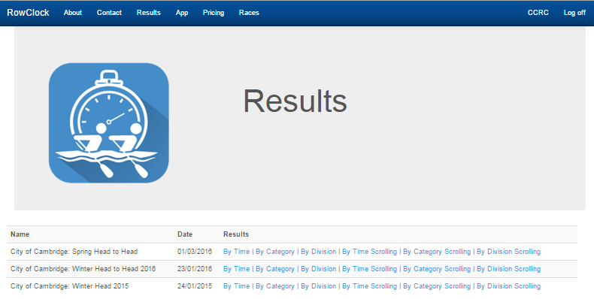
Final and Provisional results are viewable by anyone. Hidden results are only viewable by the relevant race administrator.
If you are logged in you have more options for each race – you have a scrolling version which scrolls through the results and updates the results automatically as they come in.

Downloading Results
There is a Download button on each of the timing results types – it allows you to download the results in CSV format in the order specified by that type (e.g. category then time)
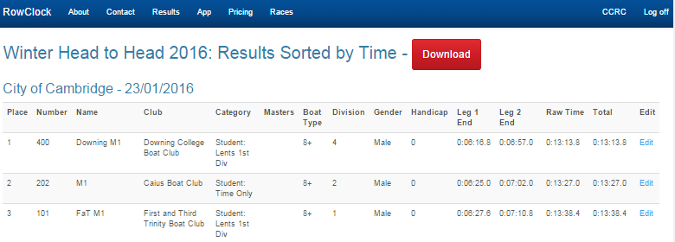

Managing Races
Clicking on the “Races” button will take you race management.
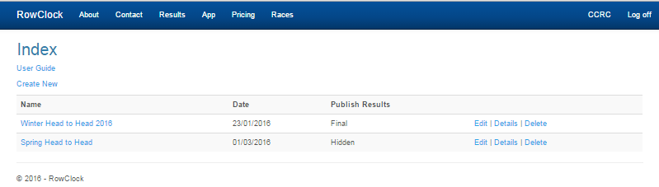
Once you have created a race it will appear in the list of races in Race Management.

Editing Races
You can edit delete a race or edit its basic details (name/date) using the “Edit” or “Delete” links. You can also “Publish” the results via the “Edit” link.
You can create a new race, from here, “Edit” the basic details, or click on the race name to go to the more advanced race management.

Basic Race Details
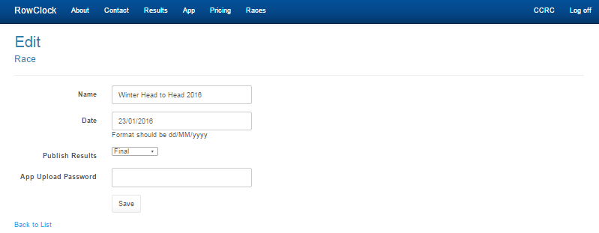
Name is the publically visible race name. It's also seen by the race timers in the App.
Date – only races on the current date or in the future are visible to race timers in the App.
Publish Results – Hidden (only you can see it), Provisional (visible to anyone, but with a Provisional heading) or Final.
App Upload Password – not your login password, but a password race timers must enter in the App to be able to upload. Can be blank if you don't want to use one.

Advanced Race Management
Enter advanced race management by clicking on the race name.
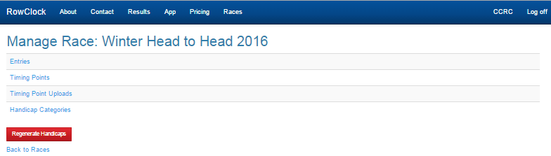
Entries manages the list of boats entered.
Timing Points manages the points you want the race timed at (e.g. Start and Finish).
Timing Point Uploads lists and allows you to manage the timings that the race timers have sent in (or upload your own versions).
Handicap Categories lists and allows you to manage the handicap categories.
Regenerate Handicaps button allows you to force the website to calculate the handicaps (using the British Rowing rules). This happens automatically ever time a set of timings is sent in.

Entries
By clicking on the Entries link in the Manage Race screen you can manage the entries to the race.
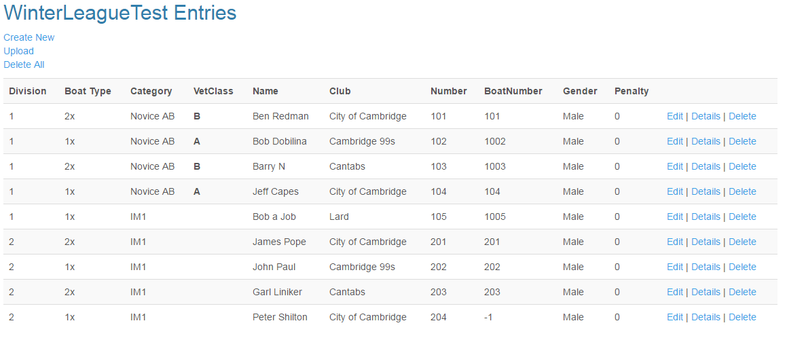You can either manually create individual entries via the “Create New” link, or upload a list of entries from a comma separated file, which can be created from a spreadsheet such as Excel by “saving as” a comma separated file (CSV).
Delete All allows you to delete all entries. This will delete any results as well, so don’t do this unless you’re sure! (You can still see any uploaded times, but they won’t be associated with the new set of entries).

Entries – Upload
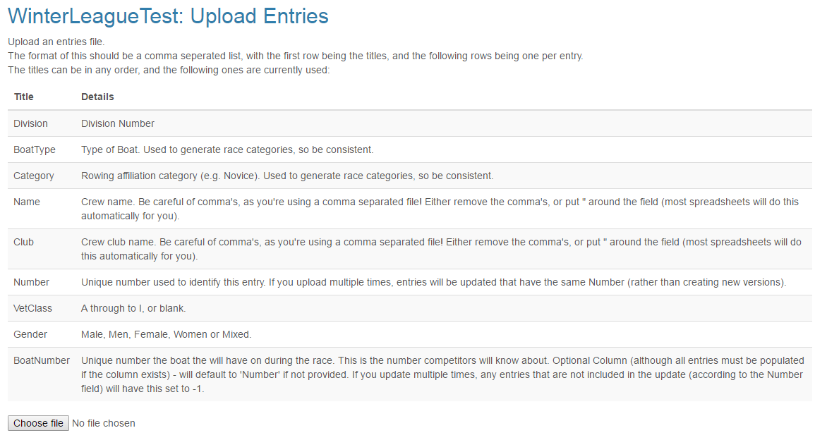
The format of this file is detailed on this page.
- The first line must have titles that match all of the ones shown in the upload screen, but there can be more (which will be ignored).
- These aren't case sensitive
- It doesn't matter what order they are in (as long as the following rows are all in that order)
- The rows all need to have the correct number of commas. If you have a field with a comma in it, this can cause problems. Either remove the comma, or put “ around the field. E.g. “Ben, fast”. Most spreadsheets will do this automatically for you.
If you upload more than once, it will attempt to match on the “Number” column and update fields rather than creating new ones. Any entries which don’t exist in the new upload will be left alone except for the BoatNumber, which will be changed to -1.
This is useful for league style races where there are likely to be some change to the entries between each leg (sub-race). The entries with -1 Boat Numbers will not show up in the timing marshal’s apps for the current race.

Editing Entries and adding a Penalty
From the main Entries screen, you can edit the penalties for any entry by clicking on “Penalties” next to that entry.
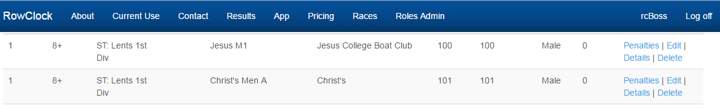
This allows you to create, edit and delete the penalties for that crew. Each penalty must be associated with a start timing point (if you don’t care, pick any – this is only really useful for multiple leg races, possibly where each leg is on a different day, where people will want to see results for each leg).
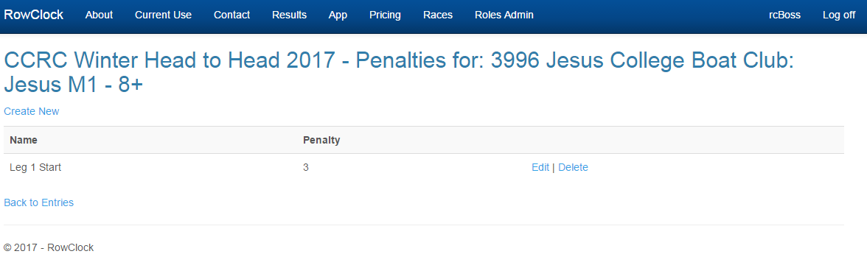

Timing Points
The Timing points define where the race will be timed. The most basic set up is a Start and a Finish, which is the default set up.
You can add more (the below example shows a race with a “pause” in the middle, so there are 2 starting points (indicated by the “Start?” column) and 2 end points.
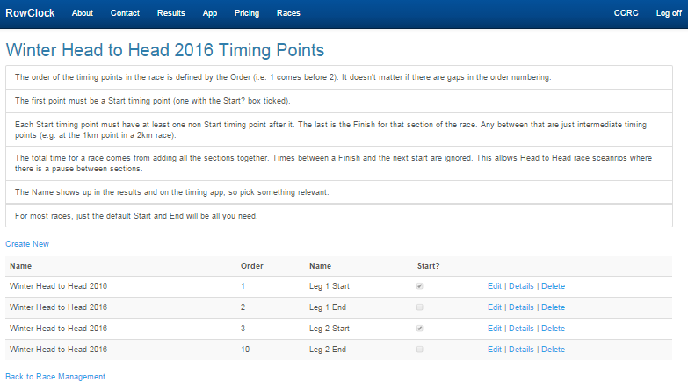
The Order field is used to put the timing points in order (it doesn't matter if these aren't consecutive numbers).
Give them sensible names as these show up in the results and in the mobile timing App.
Every Timing point which is defined as a “Start” means that it's a new section to the race. i.e. the previous timing point is the end of a section, and times between that and the next start are ignored. In the above example crews are timed from Start1 to End1, and Start2 to End2 and both these are added together.
Any timing points which aren't a Start or an End are just “split” time markers i.e. they show how crews are getting on, but aren't important for the total times.

Timing Point Uploads
This shows what result uploads have been made, by which device, and when. It also allows you to upload your own results manually.
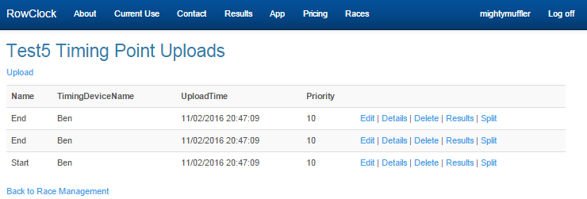

Timing Point Priority
If there is more than one result for a boat on one particular timing point (due to another upload), the upload with the highest priority is used.
If the uploads have the same priority, the upload which was done first is used (upload time can be edited if necessary).
Uploads from the mobile App have a priority of 10, so when manually uploading results, use a higher priority to overwrite, and a lower one to fill in any gaps.
This also allows you to have multiple people timing each point for redundancy.

Manual Timing Point Uploads
Click “Upload” to manually upload results.
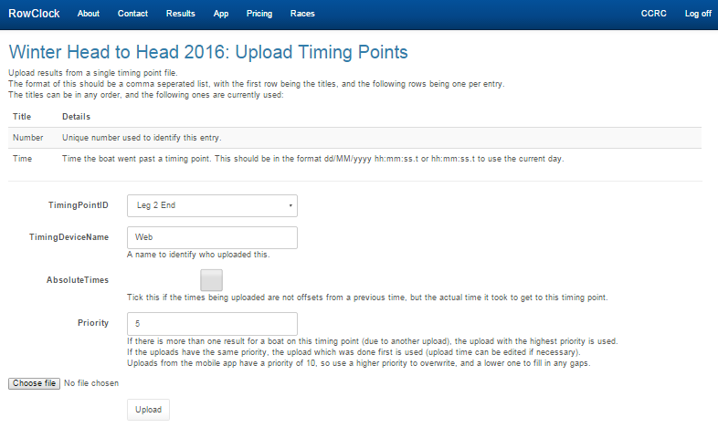
AbsoluteTimes indicates if this upload should used to work out a difference in time from another timing point upload (unticked) or should be used by itself as the time it took to get to this timing point from the associated “Start” timing point (ticked).
Uploads from the mobile App have a priority of 10, so when manually uploading results, use a higher priority to overwrite, and a lower one to fill in any gaps.

Editing Timing Point Upload
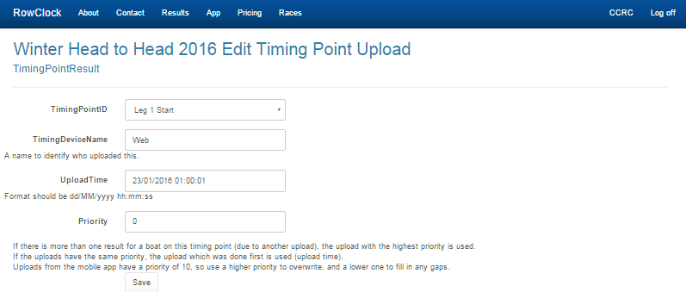
This allows you to modify the upload. This is useful if you want to change the priority of an upload.
It is also useful if someone has uploaded a set of results with the wrong timing point selected (that's shown as “Name”) as you can edit the result upload to point to the correct Timing Point.

Split Timing Point Upload
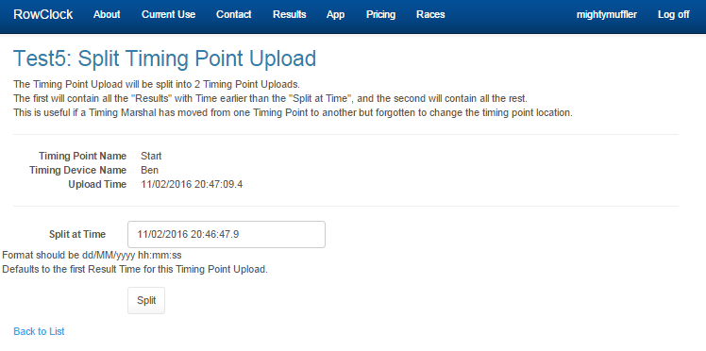
You can split a Timing Point Upload in two.
The first will contain all the "Results" with Time earlier than the "Split at Time", and the second will contain all the rest.
This is useful if a Timing Marshal has moved from one Timing Point to another but forgotten to change the timing point location.

Timing Point Upload – Individual Results
Clicking on the “Results” link of a Timing Point Upload shows the actual individual times.
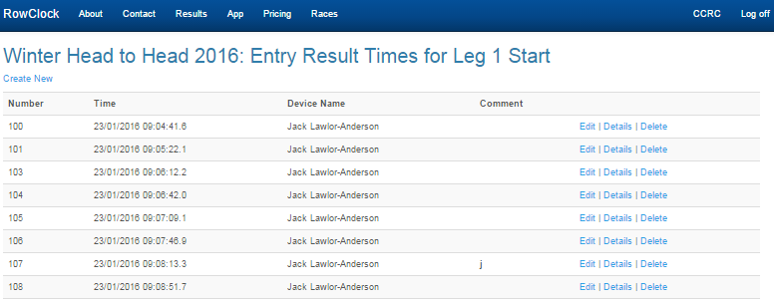
You can then edit these - this is useful if there were times taken for boats with no numbers – these will show up as negative numbers, hopefully with a comment describing them. You can edit the number.

Handicap Categories
Handicaps categories are selected by looking for entries with a value in the “Vet Class” field. The “Boat Type” and “Category” are then used to create a masters group.

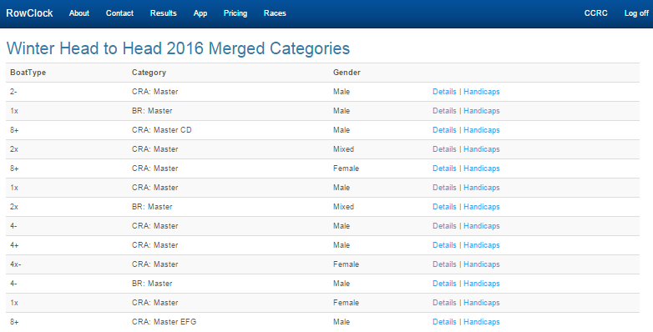
The handicaps are calculated using the British Rowing Masters Handicap system defined here:
http://www.britishrowing.org/upload/files/Association/Policies/HandicapOperatingNotes-2010.pdf
Note this means it needs to know the fastest time done for each boat type, which means the handicaps need to be calculated after the results are in.
For multi-leg races the total time is used to give a total handicap.
The handicaps are regenerated every time a timing point upload is made, but you can force it to regenerate with the button.
You can view the actual handicap amounts by following the “Handicaps” link.
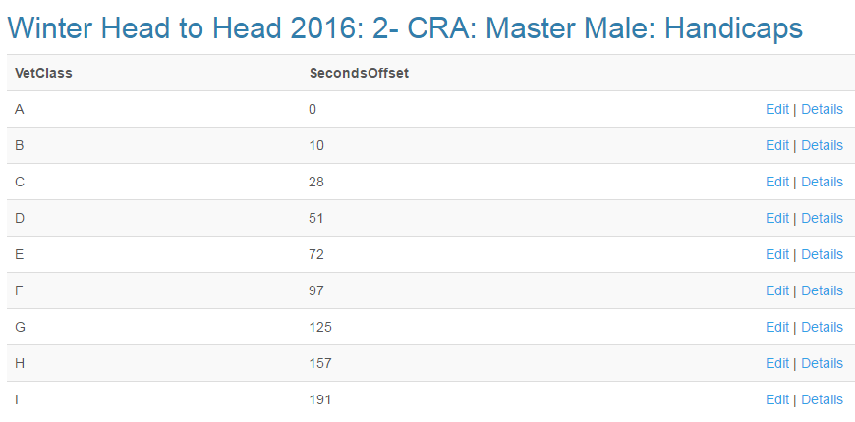
Note: If you want to stop the handicaps from updating any more, you can disable this feature from the Eidt Race screen.

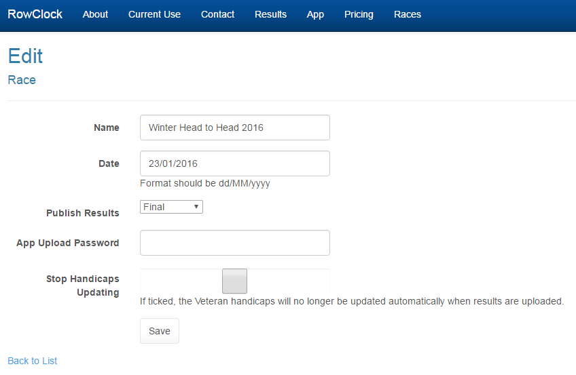
Editing results
When you are logged in you have an extra option for your races on the Results screens – Edit

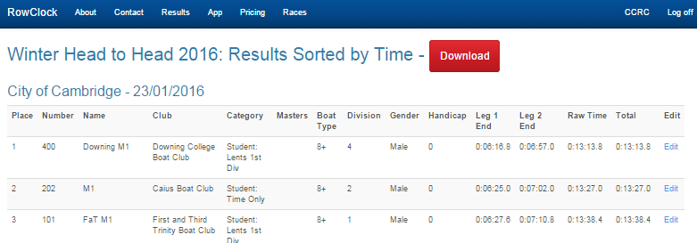
When you follow this link you can see all the times uploaded for the “Number” of the crew, from which device it was uploaded, and which timing point each is for.
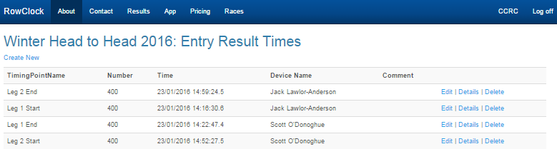
You can edit any of the times, or the number the upload is associated with.
You can also use the “Create New” link to create a new Result Time if one is missing.

Missing/Blank Numbers
If the person doing the timing is unable to work out a crews number, they can leave the number blank, but still enter the time. They can also make any useful comments they can think of to describe the crew.
On the website these times will show up as new crews with negative numbers. You can go and edit the results for these as defined in the Entry Result Times or Timing Point Uploads section, changing the number to be the crew entered you believe it to be.

New Crews
If a crew races that was not in the entries list, the person doing the timing can enter them using their number as normal. The website will create a new entry for them leaving the details blank. You can edit that entries details via the Entries screen.

Common Tasks

Merging in Backup Results
See - Manual Timing Point Uploads.

Coping with Timing Marshal putting in the wrong location
See - Editing Timing Points

Coping with “Missing” Numbers
The person using the timing App may not be able to work out a number for every boat. If so they can still get a time, but it gets a negative number.
Look at the timing point upload results to check for these, and Edit any individual upload result to change it the correct number.

Multiple Versions of the same Boat Type and Category
The Categories and Boat Type groups are worked out from the Categories and Boat Types in the entries. The is case sensitive. Any differences (spaces, miss-spellings, different capitalization etc) means the website will think it's a different category. You can edit the Entries to make them the same and the website will automatically merge them.

Merging Categories
If you want to merge categories (including Veteran categories), you just need the Boat Type and Categories field of the entries to be the same. E.g. Edit the entries and change the 4x- Category “BR: J15” and “BR: J16” could be merged by changing all the entries in those two categories to have “BR: J15 J16” as the Categories.

Coping with Timing Marshal not changing the location even though they should have
You can edit a location for a single upload via the Edit Timing Point Upload page. If they’ve moved mid race you can split the timing point upload and then edit one of the 2 resulting Timing Point Upload via the Split Timing Point page.

